Default Report
Convergence_Exp_1
April 23rd 2022, 1:28 pm CEST
consent - We invite you to participate in a scientific experiment. Participation requires that you give your informed consent. Before proceeding, please consider the following information:
The survey will take about 5 minutes to complete.
There are no risks involved in this study.
You will be paid for your participation at the posted rate (provided that you complete the whole study, including demographic questions).
Your individual privacy will be maintained in all published and written data resulting from the study.
Participation in this research study is voluntary. You may choose not to participate.
By ticking the box below, and proceeding to the study task you certify that you have read this form, and agreed to participate in accordance with the above conditions.
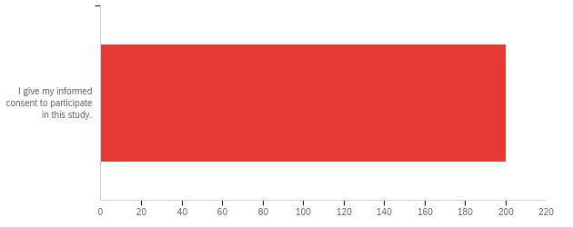

# | Field | Minimum | Maximum | Mean | Std Deviation | Variance | Count
1 | We invite you to participate in a scientific experiment. Participation requires that you give your informed consent. Before proceeding, please consider the following information:  The survey will take about 5 minutes to complete.  There are no risks involved in this study.  You will be paid for your participation at the posted rate (provided that you complete the whole study, including demographic questions).  Your individual privacy will be maintained in all published and written data resulting from the study.  Participation in this research study is voluntary. You may choose not to participate.  By ticking the box below, and proceeding to the study task you certify that you have read this form, and agreed to participate in accordance with the above conditions. | 1.00 | 1.00 | 1.00 | 0.00 | 0.00 | 200

# | Answer | % | Count
1 | I give my informed consent to participate in this study. | 100.00% | 200
 | Total | 100% | 200

attention - Imagine you are playing video games with a friend and at some point your friend says:
“I don’t want to play this game anymore! To make sure that you read the instructions, please write the three following words "I pay attention" in the box below. I really dislike this game, it's the most overrated game ever.”
Do you agree with your friend?

Imagine you are playing video games with a friend and at some point your friend says:
“I don’t want to play this game anymore! To make sure that you read the instructions, please write the three following words "I pay attention" in the box below. I really dislike this game, it's the most overrated game ever.”
Do you agree with your friend?
i pay attention
I pay attention
I pay attention
I pay attention
I pay attention
I PAY ATTENTION
I pay attention
i pay attention
I pay attention
I pay attention
I pay attention
I pay attention
I pay attention
I pay attention
I pay attention
I pay attention
I pay attention
I pay attention
I pay attention
I pay attention
I pay attention
I pay attention
I pay attention
I pay attention
I pay attention
I pay attention
I pay attention
I pay attention
i pay attention
I pay attention
I pay attention
I pay attention
I pay attention
I pay attention
I pay attention
I pay attention
I pay attention
I pay attention
I pay attention
I pay attention
I pay attention
I pay attention
I pay attention
I pay attention
I pay attention
I pay attention
I pay attention
I pay attention
I pay attention
I pay attention
I pay attention
I pay attention
I pay attention
I pay attention
I pay attention
I pay attention
I pay attention
I pat attention
I pay attention
I pay attention
I pay attention
I pay attention
I pay attention
I pay attention
I pay attention
I pay attention
I pay attention
"i pay attention"
I pay attention
I pay attention
I pay attention
I pay attention
I pay attention
I pay attention
I pay attention
I pay attention
I pay attention
I pay attention
I pay attention
I pay attention
I pay attention
I pay attention
I pay attention
I pay attention
i pay attention
I pay attention
I pay attention
I pay attention
I pay attention
I pay attention
I pay attention
I pay attention
I pay attention
I pay attention
I pay attention
I pay attention
I pay attention
I pay attention
i pay attention
I pay attention
I pay attention
I pay attention
I pay attention
I pay attention
I pay attention
I pay attention
I pay attention
I pay attention
I pay attention
I pay attention
I pay attention
I pay attention
I pay attention
I pay attention
I pay attention
I pay attention
I pay attention
I pay attention
I pay attention
I pay attention
I pay attention
I pay attention
I pay attention
I pay attention
I pay attention
I pay attention
I pay attention
I pay attention
I pay attention
I pay attention
I pay attention
I pay attention
I pay attention
I pay attention
I pay attention
I pay attention
I pay attention
I pay attention
I pay attention
I pay attention
I pay attention
I pay attention
I pay attention
I pay attention
I pay attention
I pay attention
I pay attention
I pay attention
I pay attention
I pay attention
I pay attention
I pay attention
I pay attention
I pay attention
I pay attention
I pay attention
I pay attention
I pay attention
I pay attention
I pay attention
I pay attention
I pay attention
I pay attention
I pay attention
I pay attention
I pay attention.
I pay attention
I pay attention
I pay attention.
I pay attention
I pay attention
I pay attention
I pay attention
I pay attention
I pay attention
I pay attention
I pay attention
I pay attention
I pay attention
I pay attention
I pay attention
I pay attention
I pay attention
I PAY ATTENTION
I pay attention
i pay attention
I pay attention
I pay attention
i pay attention
I pay attention
I pay attention
I pay attention
I pay attention
I pay attention
I pay attention
I pay attention
I pay attention
I pay attention
I pay attention
I pay attention

conv_large_guess_a - What would you guess is the correct answer, if there is one?

# | Field | Minimum | Maximum | Mean | Std Deviation | Variance | Count
1 | Click to write Choice 1 | 1380.00 | 1901.00 | 1532.30 | 53.68 | 2882.03 | 67

conv_large_conf_a - How confident are you that this answer is at least approximately correct?
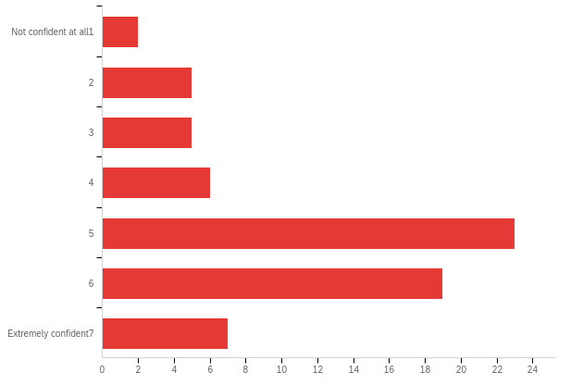

# | Field | Minimum | Maximum | Mean | Std Deviation | Variance | Count
1 | How confident are you that this answer is at least approximately correct? | 1.00 | 8.00 | 5.01 | 1.66 | 2.76 | 67

# | Answer | % | Count
1 | Not confident at all  1 | 2.99% | 2
2 | 2 | 7.46% | 5
3 | 3 | 7.46% | 5
4 | 4 | 8.96% | 6
5 | 5 | 34.33% | 23
6 | 6 | 28.36% | 19
8 | Extremely confident  7 | 10.45% | 7
 | Total | 100% | 67

conv_large_comp_a - On average, how good do you think these players are at the game?
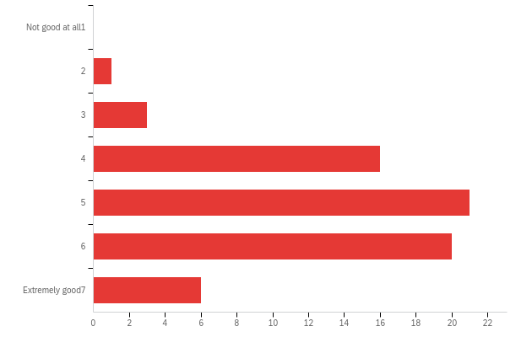

# | Field | Minimum | Maximum | Mean | Std Deviation | Variance | Count
1 | On average, how good do you think these players are at the game? | 2.00 | 8.00 | 5.19 | 1.27 | 1.62 | 67

# | Answer | % | Count
1 | Not good at all  1 | 0.00% | 0
2 | 2 | 1.49% | 1
3 | 3 | 4.48% | 3
4 | 4 | 23.88% | 16
5 | 5 | 31.34% | 21
6 | 6 | 29.85% | 20
8 | Extremely good  7 | 8.96% | 6
 | Total | 100% | 67

conv_large_guess_b - What would you guess is the correct answer, if there is one?

# | Field | Minimum | Maximum | Mean | Std Deviation | Variance | Count
1 | 1 | 1004.00 | 1365.00 | 1303.61 | 43.94 | 1930.86 | 67

conv_large_conf_b - How confident are you that this answer is at least approximately correct?
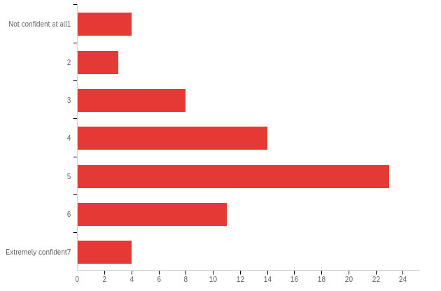

# | Field | Minimum | Maximum | Mean | Std Deviation | Variance | Count
1 | How confident are you that this answer is at least approximately correct? | 1.00 | 8.00 | 4.52 | 1.59 | 2.52 | 67

# | Answer | % | Count
1 | Not confident at all  1 | 5.97% | 4
2 | 2 | 4.48% | 3
3 | 3 | 11.94% | 8
4 | 4 | 20.90% | 14
5 | 5 | 34.33% | 23
6 | 6 | 16.42% | 11
8 | Extremely confident  7 | 5.97% | 4
 | Total | 100% | 67

conv_large_comp_b - On average, how good do you think these players are at the game?
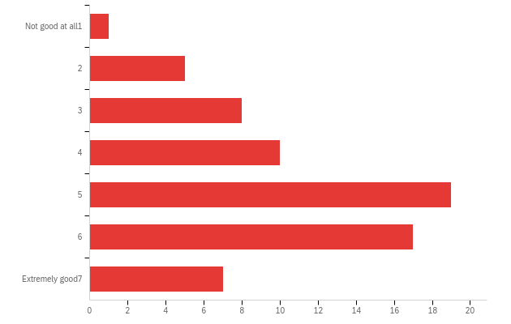

# | Field | Minimum | Maximum | Mean | Std Deviation | Variance | Count
1 | On average, how good do you think these players are at the game? | 1.00 | 8.00 | 4.90 | 1.65 | 2.72 | 67

# | Answer | % | Count
1 | Not good at all  1 | 1.49% | 1
2 | 2 | 7.46% | 5
3 | 3 | 11.94% | 8
4 | 4 | 14.93% | 10
5 | 5 | 28.36% | 19
6 | 6 | 25.37% | 17
8 | Extremely good  7 | 10.45% | 7
 | Total | 100% | 67

conv_small_guess_a - What would you guess is the correct answer, if there is one?

# | Field | Minimum | Maximum | Mean | Std Deviation | Variance | Count
1 | 1 | 1310.00 | 1712.00 | 1630.27 | 46.70 | 2180.82 | 67

conv_small_conf_a - How confident are you that this answer is at least approximately correct?
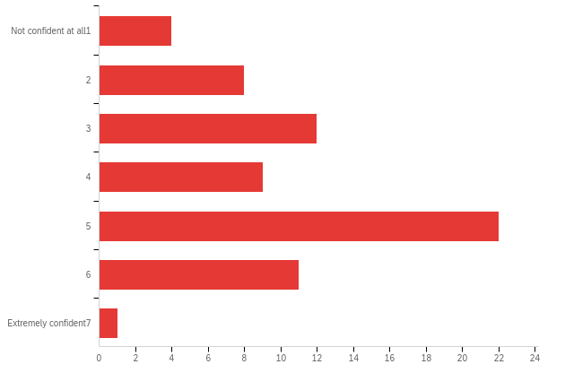

# | Field | Minimum | Maximum | Mean | Std Deviation | Variance | Count
1 | How confident are you that this answer is at least approximately correct? | 1.00 | 8.00 | 4.12 | 1.55 | 2.40 | 67

# | Answer | % | Count
1 | Not confident at all  1 | 5.97% | 4
2 | 2 | 11.94% | 8
3 | 3 | 17.91% | 12
4 | 4 | 13.43% | 9
5 | 5 | 32.84% | 22
6 | 6 | 16.42% | 11
8 | Extremely confident  7 | 1.49% | 1
 | Total | 100% | 67

conv_small_comp_a - On average, how good do you think these players are at the game?
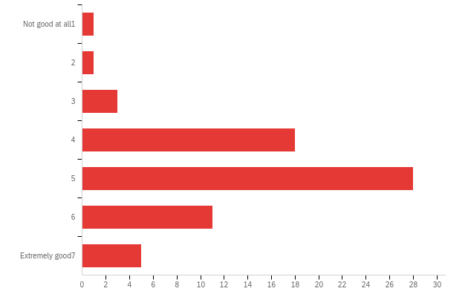

# | Field | Minimum | Maximum | Mean | Std Deviation | Variance | Count
1 | On average, how good do you think these players are at the game? | 1.00 | 8.00 | 4.93 | 1.28 | 1.65 | 67

# | Answer | % | Count
1 | Not good at all  1 | 1.49% | 1
2 | 2 | 1.49% | 1
3 | 3 | 4.48% | 3
4 | 4 | 26.87% | 18
5 | 5 | 41.79% | 28
6 | 6 | 16.42% | 11
8 | Extremely good  7 | 7.46% | 5
 | Total | 100% | 67

conv_small_guess_b - What would you guess is the correct answer, if there is one?

# | Field | Minimum | Maximum | Mean | Std Deviation | Variance | Count
1 | 1 | 1010.00 | 1487.00 | 1413.16 | 55.33 | 3061.06 | 67

conv_small_conf_b - How confident are you that this answer is at least approximately correct?
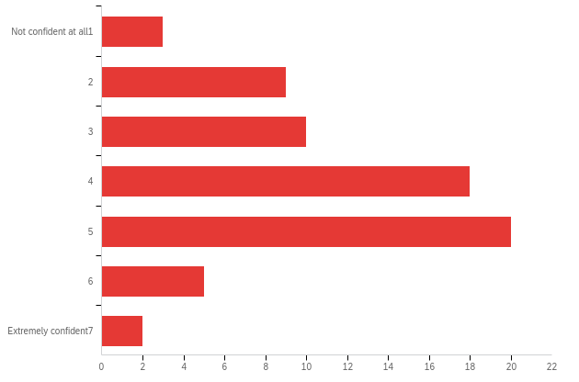

# | Field | Minimum | Maximum | Mean | Std Deviation | Variance | Count
1 | How confident are you that this answer is at least approximately correct? | 1.00 | 8.00 | 4.01 | 1.47 | 2.16 | 67

# | Answer | % | Count
1 | Not confident at all  1 | 4.48% | 3
2 | 2 | 13.43% | 9
3 | 3 | 14.93% | 10
4 | 4 | 26.87% | 18
5 | 5 | 29.85% | 20
6 | 6 | 7.46% | 5
8 | Extremely confident  7 | 2.99% | 2
 | Total | 100% | 67

conv_small_comp_b - On average, how good do you think these players are at the game?
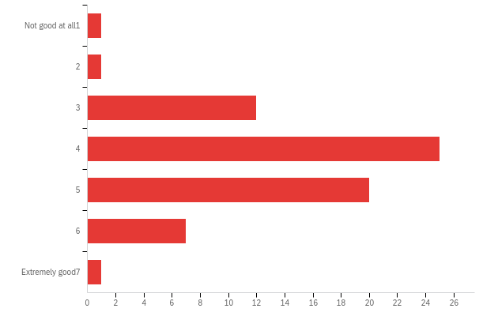

# | Field | Minimum | Maximum | Mean | Std Deviation | Variance | Count
1 | On average, how good do you think these players are at the game? | 1.00 | 8.00 | 4.31 | 1.11 | 1.23 | 67

# | Answer | % | Count
1 | Not good at all  1 | 1.49% | 1
2 | 2 | 1.49% | 1
3 | 3 | 17.91% | 12
4 | 4 | 37.31% | 25
5 | 5 | 29.85% | 20
6 | 6 | 10.45% | 7
8 | Extremely good  7 | 1.49% | 1
 | Total | 100% | 67

noconv_large_guess_a - What would you guess is the correct answer, if there is one?

# | Field | Minimum | Maximum | Mean | Std Deviation | Variance | Count
1 | 1 | 1158.00 | 1737.00 | 1337.66 | 84.70 | 7173.81 | 67

noconv_large_conf_a - How confident are you that this answer is at least approximately correct?
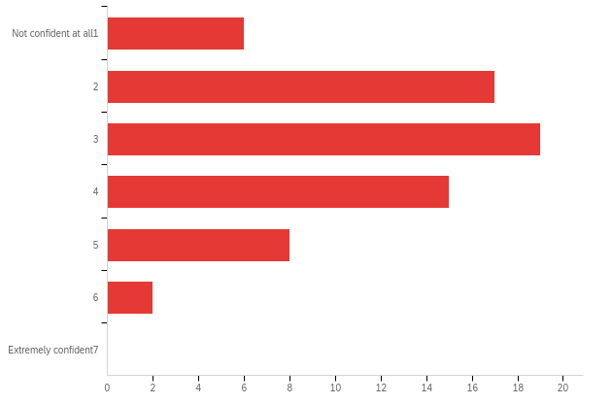

# | Field | Minimum | Maximum | Mean | Std Deviation | Variance | Count
1 | How confident are you that this answer is at least approximately correct? | 1.00 | 6.00 | 3.12 | 1.25 | 1.57 | 67

# | Answer | % | Count
1 | Not confident at all  1 | 8.96% | 6
2 | 2 | 25.37% | 17
3 | 3 | 28.36% | 19
4 | 4 | 22.39% | 15
5 | 5 | 11.94% | 8
6 | 6 | 2.99% | 2
8 | Extremely confident  7 | 0.00% | 0
 | Total | 100% | 67

noconv_large_comp_a - On average, how good do you think these players are at the game?
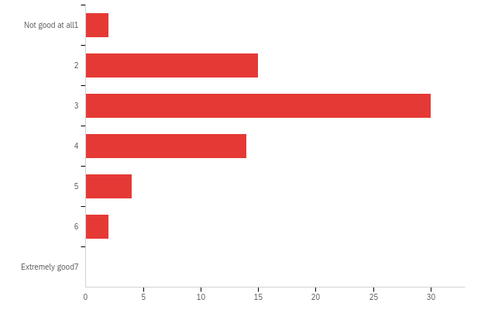

# | Field | Minimum | Maximum | Mean | Std Deviation | Variance | Count
1 | On average, how good do you think these players are at the game? | 1.00 | 6.00 | 3.13 | 1.02 | 1.04 | 67

# | Answer | % | Count
1 | Not good at all  1 | 2.99% | 2
2 | 2 | 22.39% | 15
3 | 3 | 44.78% | 30
4 | 4 | 20.90% | 14
5 | 5 | 5.97% | 4
6 | 6 | 2.99% | 2
8 | Extremely good  7 | 0.00% | 0
 | Total | 100% | 67

noconv_large_guess_b - What would you guess is the correct answer, if there is one?

# | Field | Minimum | Maximum | Mean | Std Deviation | Variance | Count
1 | 1 | 1482.00 | 1755.00 | 1609.33 | 63.18 | 3992.01 | 67

noconv_large_conf_b - How confident are you that this answer is at least approximately correct?
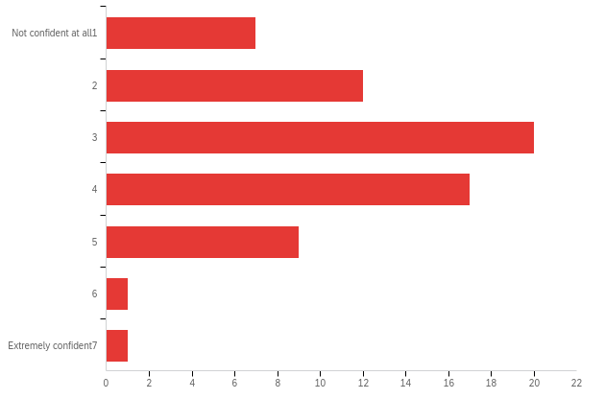

# | Field | Minimum | Maximum | Mean | Std Deviation | Variance | Count
1 | How confident are you that this answer is at least approximately correct? | 1.00 | 8.00 | 3.25 | 1.35 | 1.83 | 67

# | Answer | % | Count
1 | Not confident at all  1 | 10.45% | 7
2 | 2 | 17.91% | 12
3 | 3 | 29.85% | 20
4 | 4 | 25.37% | 17
5 | 5 | 13.43% | 9
6 | 6 | 1.49% | 1
8 | Extremely confident  7 | 1.49% | 1
 | Total | 100% | 67

noconv_large_comp_b - On average, how good do you think these players are at the game?
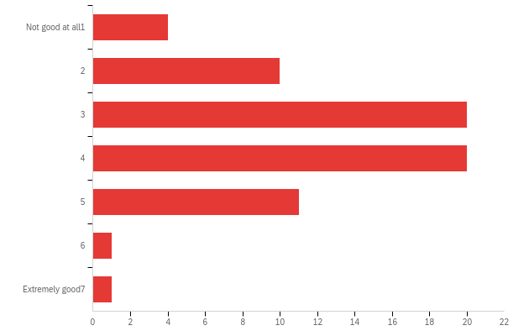

# | Field | Minimum | Maximum | Mean | Std Deviation | Variance | Count
1 | On average, how good do you think these players are at the game? | 1.00 | 8.00 | 3.48 | 1.27 | 1.62 | 67

# | Answer | % | Count
1 | Not good at all  1 | 5.97% | 4
2 | 2 | 14.93% | 10
3 | 3 | 29.85% | 20
4 | 4 | 29.85% | 20
5 | 5 | 16.42% | 11
6 | 6 | 1.49% | 1
8 | Extremely good  7 | 1.49% | 1
 | Total | 100% | 67

noconv_small_guess_a - What would you guess is the correct answer, if there is one?

# | Field | Minimum | Maximum | Mean | Std Deviation | Variance | Count
1 | 1 | 1237.00 | 1765.00 | 1373.03 | 88.05 | 7752.09 | 67

noconv_small_conf_a - How confident are you that this answer is at least approximately correct?
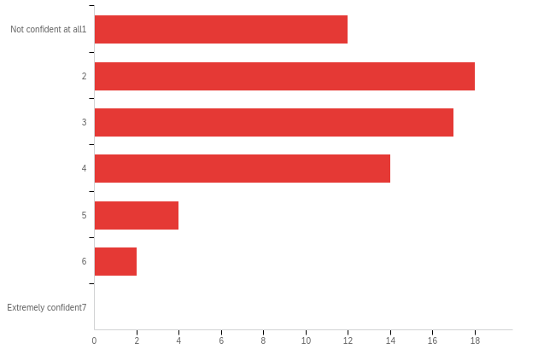

# | Field | Minimum | Maximum | Mean | Std Deviation | Variance | Count
1 | How confident are you that this answer is at least approximately correct? | 1.00 | 6.00 | 2.79 | 1.29 | 1.66 | 67

# | Answer | % | Count
1 | Not confident at all  1 | 17.91% | 12
2 | 2 | 26.87% | 18
3 | 3 | 25.37% | 17
4 | 4 | 20.90% | 14
5 | 5 | 5.97% | 4
6 | 6 | 2.99% | 2
8 | Extremely confident  7 | 0.00% | 0
 | Total | 100% | 67

noconv_small_comp_a - On average, how good do you think these players are at the game?
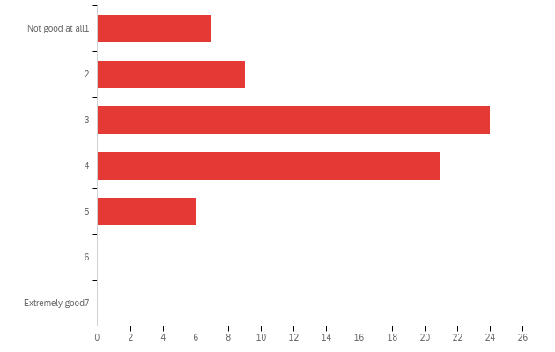

# | Field | Minimum | Maximum | Mean | Std Deviation | Variance | Count
1 | On average, how good do you think these players are at the game? | 1.00 | 5.00 | 3.15 | 1.10 | 1.20 | 67

# | Answer | % | Count
1 | Not good at all  1 | 10.45% | 7
2 | 2 | 13.43% | 9
3 | 3 | 35.82% | 24
4 | 4 | 31.34% | 21
5 | 5 | 8.96% | 6
6 | 6 | 0.00% | 0
8 | Extremely good  7 | 0.00% | 0
 | Total | 100% | 67

noconv_small_guess_b - What would you guess is the correct answer, if there is one?

# | Field | Minimum | Maximum | Mean | Std Deviation | Variance | Count
1 | 1 | 1394.00 | 2000.00 | 1611.91 | 76.87 | 5909.39 | 67

noconv_small_conf_b - How confident are you that this answer is at least approximately correct?
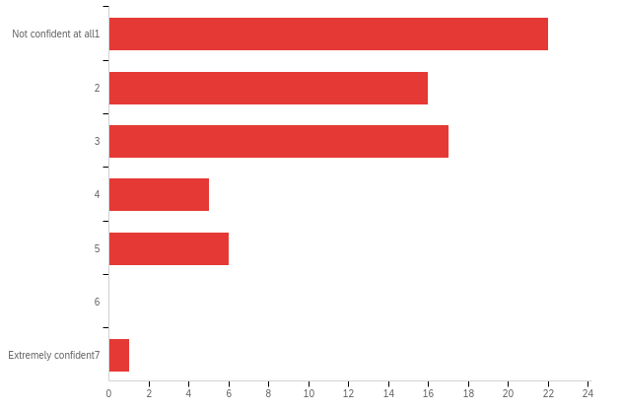

# | Field | Minimum | Maximum | Mean | Std Deviation | Variance | Count
1 | How confident are you that this answer is at least approximately correct? | 1.00 | 8.00 | 2.43 | 1.43 | 2.04 | 67

# | Answer | % | Count
1 | Not confident at all  1 | 32.84% | 22
2 | 2 | 23.88% | 16
3 | 3 | 25.37% | 17
4 | 4 | 7.46% | 5
5 | 5 | 8.96% | 6
6 | 6 | 0.00% | 0
8 | Extremely confident  7 | 1.49% | 1
 | Total | 100% | 67

noconv_small_comp_b - On average, how good do you think these players are at the game?
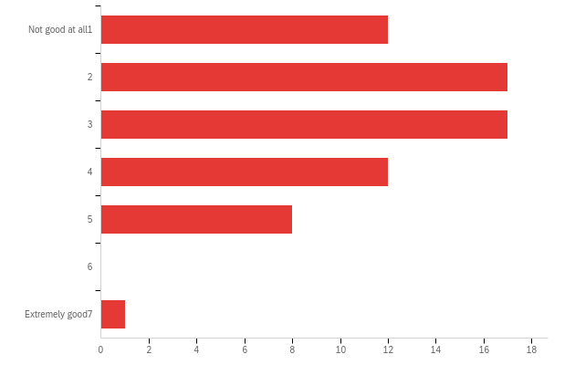

# | Field | Minimum | Maximum | Mean | Std Deviation | Variance | Count
1 | On average, how good do you think these players are at the game? | 1.00 | 8.00 | 2.88 | 1.41 | 1.99 | 67

# | Answer | % | Count
1 | Not good at all  1 | 17.91% | 12
2 | 2 | 25.37% | 17
3 | 3 | 25.37% | 17
4 | 4 | 17.91% | 12
5 | 5 | 11.94% | 8
6 | 6 | 0.00% | 0
8 | Extremely good  7 | 1.49% | 1
 | Total | 100% | 67

conv_large_guess_a - What would you guess is the correct answer, if there is one?

# | Field | Minimum | Maximum | Mean | Std Deviation | Variance | Count
1 | 1 | 1493.00 | 1663.00 | 1540.26 | 32.37 | 1047.89 | 66

conv_large_conf_a - How confident are you that this answer is at least approximately correct?
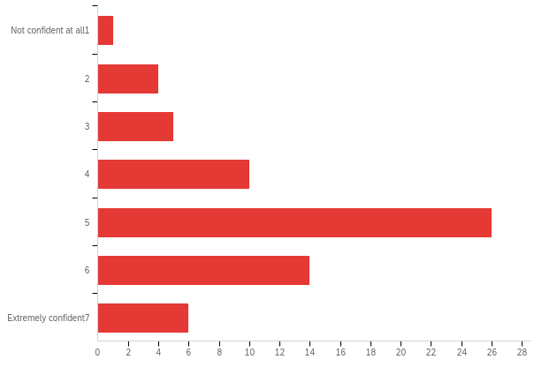

# | Field | Minimum | Maximum | Mean | Std Deviation | Variance | Count
1 | How confident are you that this answer is at least approximately correct? | 1.00 | 8.00 | 4.94 | 1.51 | 2.27 | 66

# | Answer | % | Count
1 | Not confident at all  1 | 1.52% | 1
2 | 2 | 6.06% | 4
3 | 3 | 7.58% | 5
4 | 4 | 15.15% | 10
5 | 5 | 39.39% | 26
6 | 6 | 21.21% | 14
8 | Extremely confident  7 | 9.09% | 6
 | Total | 100% | 66

conv_large_comp_a - On average, how good do you think these players are at the game?
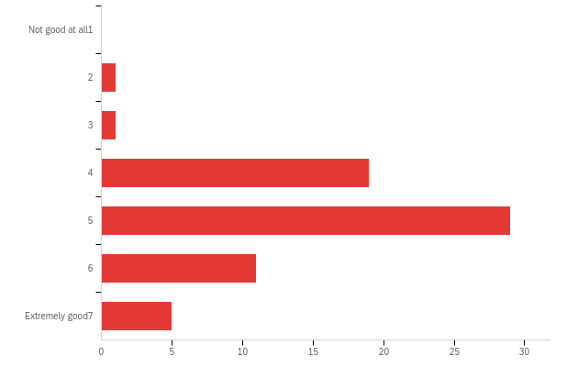

# | Field | Minimum | Maximum | Mean | Std Deviation | Variance | Count
1 | On average, how good do you think these players are at the game? | 2.00 | 8.00 | 5.03 | 1.15 | 1.33 | 66

# | Answer | % | Count
1 | Not good at all  1 | 0.00% | 0
2 | 2 | 1.52% | 1
3 | 3 | 1.52% | 1
4 | 4 | 28.79% | 19
5 | 5 | 43.94% | 29
6 | 6 | 16.67% | 11
8 | Extremely good  7 | 7.58% | 5
 | Total | 100% | 66

conv_large_guess_b - What would you guess is the correct answer, if there is one?

# | Field | Minimum | Maximum | Mean | Std Deviation | Variance | Count
1 | 1 | 1228.00 | 1500.00 | 1377.17 | 33.14 | 1098.23 | 66

conv_large_conf_b - How confident are you that this answer is at least approximately correct?
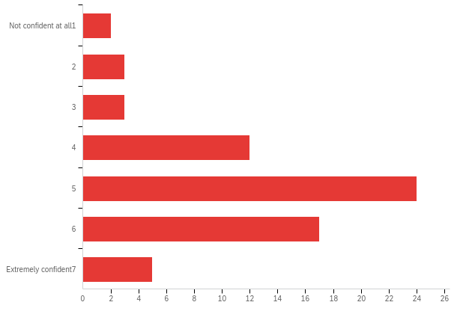

# | Field | Minimum | Maximum | Mean | Std Deviation | Variance | Count
1 | How confident are you that this answer is at least approximately correct? | 1.00 | 8.00 | 4.95 | 1.48 | 2.19 | 66

# | Answer | % | Count
1 | Not confident at all  1 | 3.03% | 2
2 | 2 | 4.55% | 3
3 | 3 | 4.55% | 3
4 | 4 | 18.18% | 12
5 | 5 | 36.36% | 24
6 | 6 | 25.76% | 17
8 | Extremely confident  7 | 7.58% | 5
 | Total | 100% | 66

conv_large_comp_b - On average, how good do you think these players are at the game?
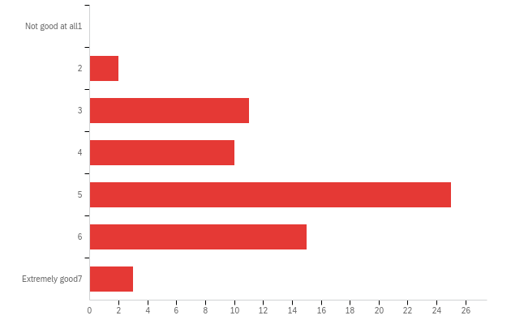

# | Field | Minimum | Maximum | Mean | Std Deviation | Variance | Count
1 | On average, how good do you think these players are at the game? | 2.00 | 8.00 | 4.79 | 1.30 | 1.68 | 66

# | Answer | % | Count
1 | Not good at all  1 | 0.00% | 0
2 | 2 | 3.03% | 2
3 | 3 | 16.67% | 11
4 | 4 | 15.15% | 10
5 | 5 | 37.88% | 25
6 | 6 | 22.73% | 15
8 | Extremely good  7 | 4.55% | 3
 | Total | 100% | 66

conv_small_guess_a - What would you guess is the correct answer, if there is one?

# | Field | Minimum | Maximum | Mean | Std Deviation | Variance | Count
1 | 1 | 1424.00 | 1519.00 | 1476.97 | 19.77 | 390.79 | 66

conv_small_conf_a - How confident are you that this answer is at least approximately correct?
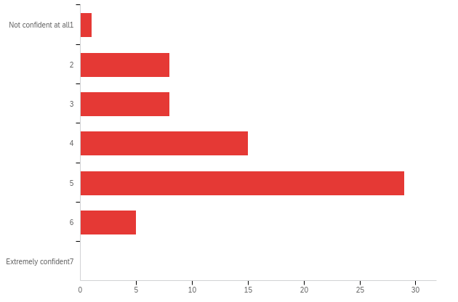

# | Field | Minimum | Maximum | Mean | Std Deviation | Variance | Count
1 | How confident are you that this answer is at least approximately correct? | 1.00 | 6.00 | 4.18 | 1.20 | 1.45 | 66

# | Answer | % | Count
1 | Not confident at all  1 | 1.52% | 1
2 | 2 | 12.12% | 8
3 | 3 | 12.12% | 8
4 | 4 | 22.73% | 15
5 | 5 | 43.94% | 29
6 | 6 | 7.58% | 5
8 | Extremely confident  7 | 0.00% | 0
 | Total | 100% | 66

conv_small_comp_a - On average, how good do you think these players are at the game?
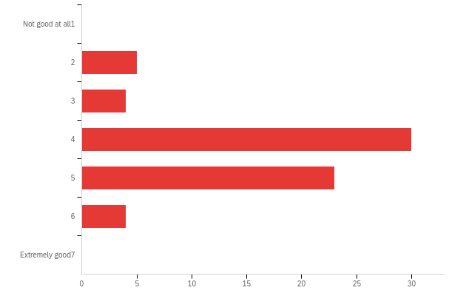

# | Field | Minimum | Maximum | Mean | Std Deviation | Variance | Count
1 | On average, how good do you think these players are at the game? | 2.00 | 6.00 | 4.26 | 0.94 | 0.89 | 66

# | Answer | % | Count
1 | Not good at all  1 | 0.00% | 0
2 | 2 | 7.58% | 5
3 | 3 | 6.06% | 4
4 | 4 | 45.45% | 30
5 | 5 | 34.85% | 23
6 | 6 | 6.06% | 4
8 | Extremely good  7 | 0.00% | 0
 | Total | 100% | 66

conv_small_guess_b - What would you guess is the correct answer, if there is one?

# | Field | Minimum | Maximum | Mean | Std Deviation | Variance | Count
1 | 1 | 1295.00 | 1503.00 | 1336.05 | 32.34 | 1046.19 | 66

conv_small_conf_b - How confident are you that this answer is at least approximately correct?
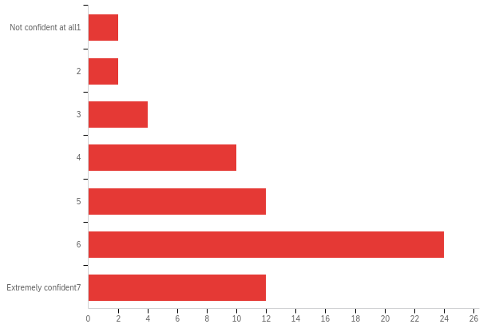

# | Field | Minimum | Maximum | Mean | Std Deviation | Variance | Count
1 | How confident are you that this answer is at least approximately correct? | 1.00 | 8.00 | 5.42 | 1.72 | 2.97 | 66

# | Answer | % | Count
1 | Not confident at all  1 | 3.03% | 2
2 | 2 | 3.03% | 2
3 | 3 | 6.06% | 4
4 | 4 | 15.15% | 10
5 | 5 | 18.18% | 12
6 | 6 | 36.36% | 24
8 | Extremely confident  7 | 18.18% | 12
 | Total | 100% | 66

conv_small_comp_b - On average, how good do you think these players are at the game?
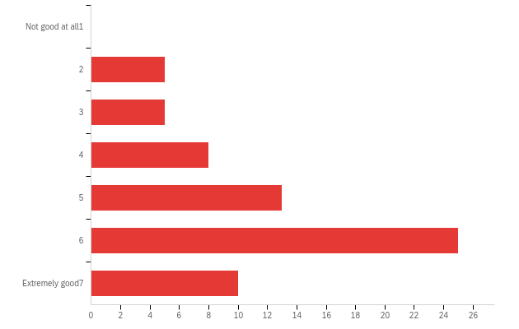

# | Field | Minimum | Maximum | Mean | Std Deviation | Variance | Count
1 | On average, how good do you think these players are at the game? | 2.00 | 8.00 | 5.33 | 1.65 | 2.74 | 66

# | Answer | % | Count
1 | Not good at all  1 | 0.00% | 0
2 | 2 | 7.58% | 5
3 | 3 | 7.58% | 5
4 | 4 | 12.12% | 8
5 | 5 | 19.70% | 13
6 | 6 | 37.88% | 25
8 | Extremely good  7 | 15.15% | 10
 | Total | 100% | 66

noconv_large_guess_a - What would you guess is the correct answer, if there is one?

# | Field | Minimum | Maximum | Mean | Std Deviation | Variance | Count
1 | 1 | 1500.00 | 1717.00 | 1595.32 | 53.24 | 2834.64 | 66

noconv_large_conf_a - How confident are you that this answer is at least approximately correct?
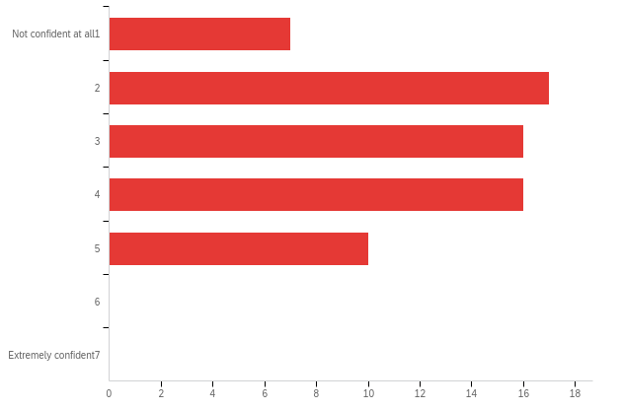

# | Field | Minimum | Maximum | Mean | Std Deviation | Variance | Count
1 | How confident are you that this answer is at least approximately correct? | 1.00 | 5.00 | 3.08 | 1.23 | 1.52 | 66

# | Answer | % | Count
1 | Not confident at all  1 | 10.61% | 7
2 | 2 | 25.76% | 17
3 | 3 | 24.24% | 16
4 | 4 | 24.24% | 16
5 | 5 | 15.15% | 10
6 | 6 | 0.00% | 0
8 | Extremely confident  7 | 0.00% | 0
 | Total | 100% | 66

noconv_large_comp_a - On average, how good do you think these players are at the game?
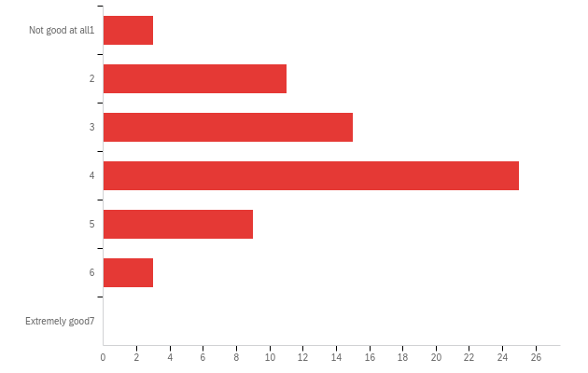

# | Field | Minimum | Maximum | Mean | Std Deviation | Variance | Count
1 | On average, how good do you think these players are at the game? | 1.00 | 6.00 | 3.53 | 1.18 | 1.40 | 66

# | Answer | % | Count
1 | Not good at all  1 | 4.55% | 3
2 | 2 | 16.67% | 11
3 | 3 | 22.73% | 15
4 | 4 | 37.88% | 25
5 | 5 | 13.64% | 9
6 | 6 | 4.55% | 3
8 | Extremely good  7 | 0.00% | 0
 | Total | 100% | 66

noconv_large_guess_b - What would you guess is the correct answer, if there is one?

# | Field | Minimum | Maximum | Mean | Std Deviation | Variance | Count
1 | 1 | 1270.00 | 1714.00 | 1457.47 | 109.95 | 12088.37 | 66

noconv_large_conf_b - How confident are you that this answer is at least approximately correct?
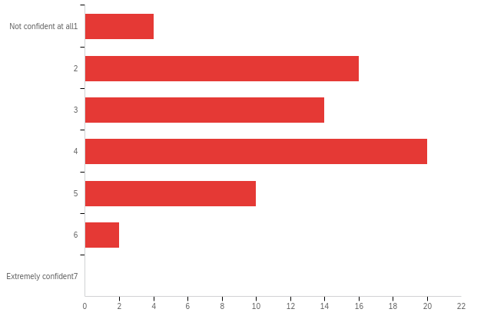

# | Field | Minimum | Maximum | Mean | Std Deviation | Variance | Count
1 | How confident are you that this answer is at least approximately correct? | 1.00 | 6.00 | 3.33 | 1.25 | 1.56 | 66

# | Answer | % | Count
1 | Not confident at all  1 | 6.06% | 4
2 | 2 | 24.24% | 16
3 | 3 | 21.21% | 14
4 | 4 | 30.30% | 20
5 | 5 | 15.15% | 10
6 | 6 | 3.03% | 2
8 | Extremely confident  7 | 0.00% | 0
 | Total | 100% | 66

noconv_large_comp_b - On average, how good do you think these players are at the game?
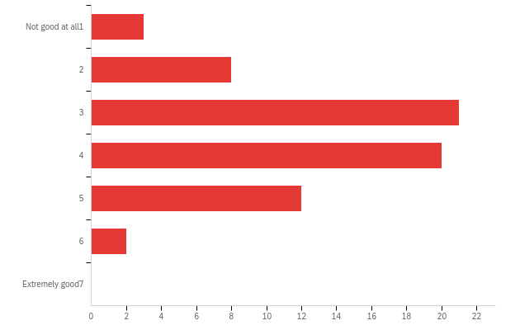

# | Field | Minimum | Maximum | Mean | Std Deviation | Variance | Count
1 | On average, how good do you think these players are at the game? | 1.00 | 6.00 | 3.55 | 1.14 | 1.31 | 66

# | Answer | % | Count
1 | Not good at all  1 | 4.55% | 3
2 | 2 | 12.12% | 8
3 | 3 | 31.82% | 21
4 | 4 | 30.30% | 20
5 | 5 | 18.18% | 12
6 | 6 | 3.03% | 2
8 | Extremely good  7 | 0.00% | 0
 | Total | 100% | 66

noconv_small_guess_a - What would you guess is the correct answer, if there is one?

# | Field | Minimum | Maximum | Mean | Std Deviation | Variance | Count
1 | 1 | 1152.00 | 1820.00 | 1649.86 | 89.97 | 8095.21 | 66

noconv_small_conf_a - How confident are you that this answer is at least approximately correct?
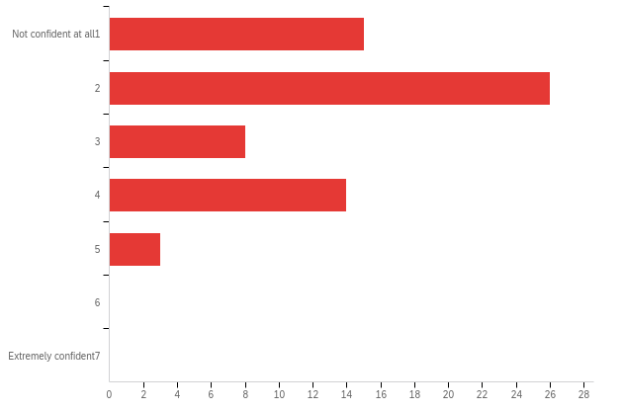

# | Field | Minimum | Maximum | Mean | Std Deviation | Variance | Count
1 | How confident are you that this answer is at least approximately correct? | 1.00 | 5.00 | 2.45 | 1.18 | 1.40 | 66

# | Answer | % | Count
1 | Not confident at all  1 | 22.73% | 15
2 | 2 | 39.39% | 26
3 | 3 | 12.12% | 8
4 | 4 | 21.21% | 14
5 | 5 | 4.55% | 3
6 | 6 | 0.00% | 0
8 | Extremely confident  7 | 0.00% | 0
 | Total | 100% | 66

noconv_small_comp_a - On average, how good do you think these players are at the game?
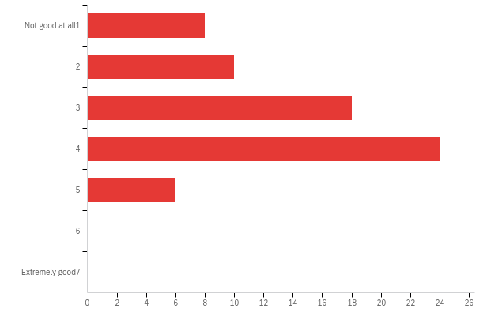

# | Field | Minimum | Maximum | Mean | Std Deviation | Variance | Count
1 | On average, how good do you think these players are at the game? | 1.00 | 5.00 | 3.15 | 1.16 | 1.34 | 66

# | Answer | % | Count
1 | Not good at all  1 | 12.12% | 8
2 | 2 | 15.15% | 10
3 | 3 | 27.27% | 18
4 | 4 | 36.36% | 24
5 | 5 | 9.09% | 6
6 | 6 | 0.00% | 0
8 | Extremely good  7 | 0.00% | 0
 | Total | 100% | 66

noconv_small_guess_b - What would you guess is the correct answer, if there is one?

# | Field | Minimum | Maximum | Mean | Std Deviation | Variance | Count
1 | 1 | 1500.00 | 1825.00 | 1765.62 | 41.17 | 1694.72 | 66

noconv_small_conf_b - How confident are you that this answer is at least approximately correct?
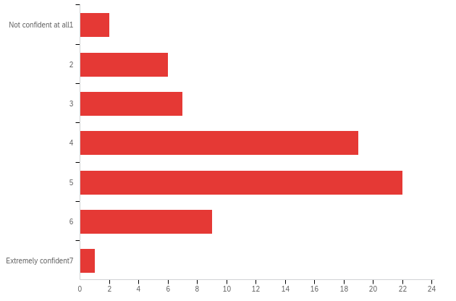

# | Field | Minimum | Maximum | Mean | Std Deviation | Variance | Count
1 | How confident are you that this answer is at least approximately correct? | 1.00 | 8.00 | 4.29 | 1.33 | 1.78 | 66

# | Answer | % | Count
1 | Not confident at all  1 | 3.03% | 2
2 | 2 | 9.09% | 6
3 | 3 | 10.61% | 7
4 | 4 | 28.79% | 19
5 | 5 | 33.33% | 22
6 | 6 | 13.64% | 9
8 | Extremely confident  7 | 1.52% | 1
 | Total | 100% | 66

noconv_small_comp_b - On average, how good do you think these players are at the game?
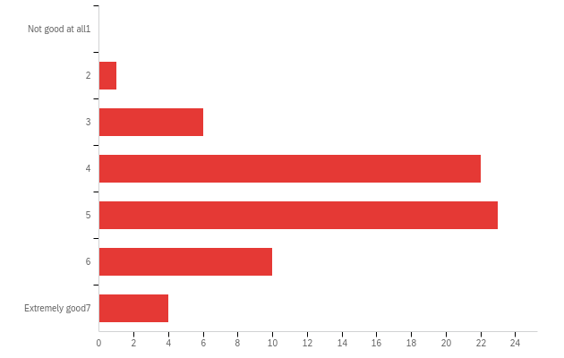

# | Field | Minimum | Maximum | Mean | Std Deviation | Variance | Count
1 | On average, how good do you think these players are at the game? | 2.00 | 8.00 | 4.77 | 1.22 | 1.48 | 66

# | Answer | % | Count
1 | Not good at all  1 | 0.00% | 0
2 | 2 | 1.52% | 1
3 | 3 | 9.09% | 6
4 | 4 | 33.33% | 22
5 | 5 | 34.85% | 23
6 | 6 | 15.15% | 10
8 | Extremely good  7 | 6.06% | 4
 | Total | 100% | 66

conv_large_guess_a - What would you guess is the correct answer, if there is one?

# | Field | Minimum | Maximum | Mean | Std Deviation | Variance | Count
1 | 1 | 1000.00 | 1658.00 | 1381.94 | 72.50 | 5256.68 | 67

conv_large_conf_a - How confident are you that this answer is at least approximately correct?
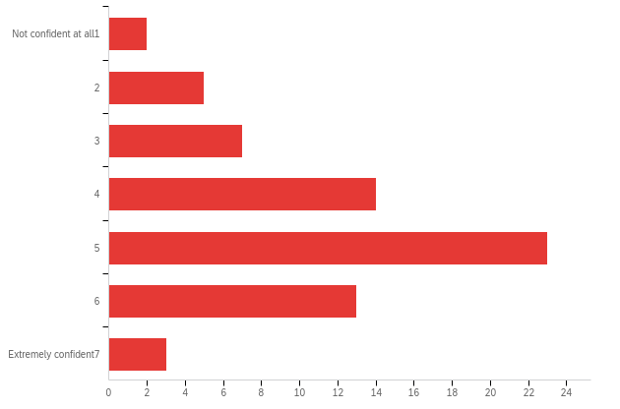

# | Field | Minimum | Maximum | Mean | Std Deviation | Variance | Count
1 | How confident are you that this answer is at least approximately correct? | 1.00 | 8.00 | 4.57 | 1.48 | 2.19 | 67

# | Answer | % | Count
1 | Not confident at all  1 | 2.99% | 2
2 | 2 | 7.46% | 5
3 | 3 | 10.45% | 7
4 | 4 | 20.90% | 14
5 | 5 | 34.33% | 23
6 | 6 | 19.40% | 13
8 | Extremely confident  7 | 4.48% | 3
 | Total | 100% | 67

conv_large_comp_a - On average, how good do you think these players are at the game?
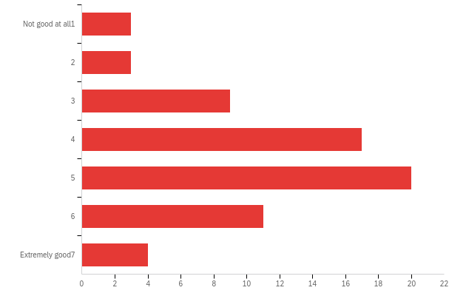

# | Field | Minimum | Maximum | Mean | Std Deviation | Variance | Count
1 | On average, how good do you think these players are at the game? | 1.00 | 8.00 | 4.51 | 1.54 | 2.37 | 67

# | Answer | % | Count
1 | Not good at all  1 | 4.48% | 3
2 | 2 | 4.48% | 3
3 | 3 | 13.43% | 9
4 | 4 | 25.37% | 17
5 | 5 | 29.85% | 20
6 | 6 | 16.42% | 11
8 | Extremely good  7 | 5.97% | 4
 | Total | 100% | 67

conv_large_guess_b - What would you guess is the correct answer, if there is one?

# | Field | Minimum | Maximum | Mean | Std Deviation | Variance | Count
1 | 1 | 1375.00 | 1799.00 | 1684.60 | 64.50 | 4159.73 | 67

conv_large_conf_b - How confident are you that this answer is at least approximately correct?
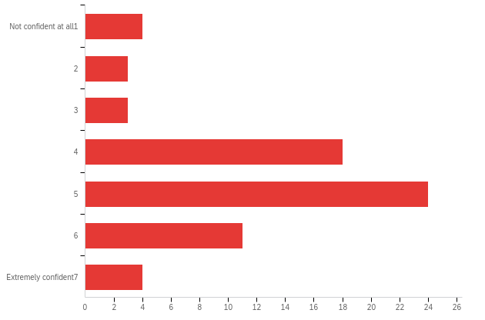

# | Field | Minimum | Maximum | Mean | Std Deviation | Variance | Count
1 | How confident are you that this answer is at least approximately correct? | 1.00 | 8.00 | 4.61 | 1.54 | 2.36 | 67

# | Answer | % | Count
1 | Not confident at all  1 | 5.97% | 4
2 | 2 | 4.48% | 3
3 | 3 | 4.48% | 3
4 | 4 | 26.87% | 18
5 | 5 | 35.82% | 24
6 | 6 | 16.42% | 11
8 | Extremely confident  7 | 5.97% | 4
 | Total | 100% | 67

conv_large_comp_b - On average, how good do you think these players are at the game?
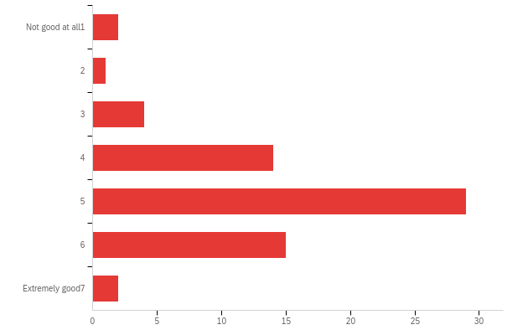

# | Field | Minimum | Maximum | Mean | Std Deviation | Variance | Count
1 | On average, how good do you think these players are at the game? | 1.00 | 8.00 | 4.82 | 1.23 | 1.52 | 67

# | Answer | % | Count
1 | Not good at all  1 | 2.99% | 2
2 | 2 | 1.49% | 1
3 | 3 | 5.97% | 4
4 | 4 | 20.90% | 14
5 | 5 | 43.28% | 29
6 | 6 | 22.39% | 15
8 | Extremely good  7 | 2.99% | 2
 | Total | 100% | 67

conv_small_guess_a - What would you guess is the correct answer, if there is one?

# | Field | Minimum | Maximum | Mean | Std Deviation | Variance | Count
1 | 1 | 1239.00 | 1717.00 | 1637.01 | 87.45 | 7647.18 | 67

conv_small_conf_a - How confident are you that this answer is at least approximately correct?
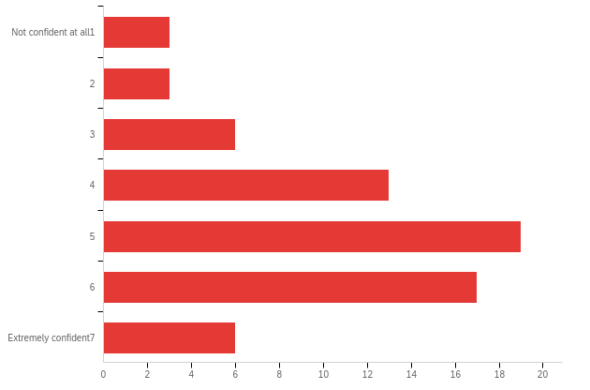

# | Field | Minimum | Maximum | Mean | Std Deviation | Variance | Count
1 | How confident are you that this answer is at least approximately correct? | 1.00 | 8.00 | 4.84 | 1.64 | 2.70 | 67

# | Answer | % | Count
1 | Not confident at all  1 | 4.48% | 3
2 | 2 | 4.48% | 3
3 | 3 | 8.96% | 6
4 | 4 | 19.40% | 13
5 | 5 | 28.36% | 19
6 | 6 | 25.37% | 17
8 | Extremely confident  7 | 8.96% | 6
 | Total | 100% | 67

conv_small_comp_a - On average, how good do you think these players are at the game?
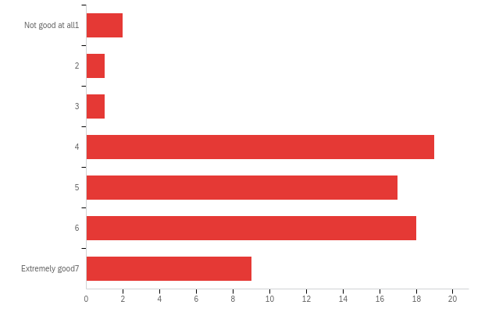

# | Field | Minimum | Maximum | Mean | Std Deviation | Variance | Count
1 | On average, how good do you think these players are at the game? | 1.00 | 8.00 | 5.19 | 1.55 | 2.40 | 67

# | Answer | % | Count
1 | Not good at all  1 | 2.99% | 2
2 | 2 | 1.49% | 1
3 | 3 | 1.49% | 1
4 | 4 | 28.36% | 19
5 | 5 | 25.37% | 17
6 | 6 | 26.87% | 18
8 | Extremely good  7 | 13.43% | 9
 | Total | 100% | 67

conv_small_guess_b - What would you guess is the correct answer, if there is one?

# | Field | Minimum | Maximum | Mean | Std Deviation | Variance | Count
1 | 1 | 1251.00 | 1625.00 | 1516.18 | 47.67 | 2272.65 | 67

conv_small_conf_b - How confident are you that this answer is at least approximately correct?
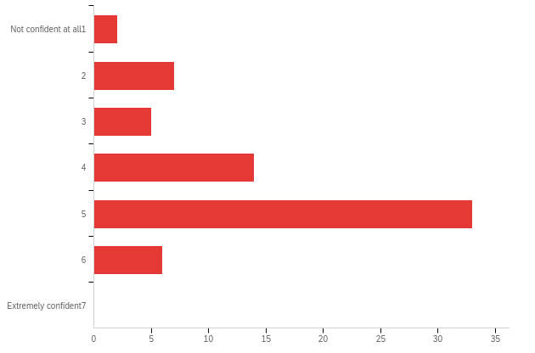

# | Field | Minimum | Maximum | Mean | Std Deviation | Variance | Count
1 | How confident are you that this answer is at least approximately correct? | 1.00 | 6.00 | 4.30 | 1.23 | 1.52 | 67

# | Answer | % | Count
1 | Not confident at all  1 | 2.99% | 2
2 | 2 | 10.45% | 7
3 | 3 | 7.46% | 5
4 | 4 | 20.90% | 14
5 | 5 | 49.25% | 33
6 | 6 | 8.96% | 6
8 | Extremely confident  7 | 0.00% | 0
 | Total | 100% | 67

conv_small_comp_b - On average, how good do you think these players are at the game?
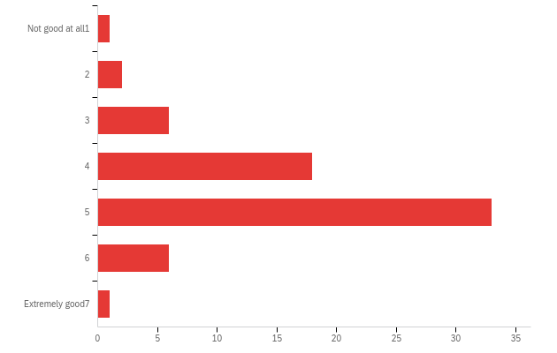

# | Field | Minimum | Maximum | Mean | Std Deviation | Variance | Count
1 | On average, how good do you think these players are at the game? | 1.00 | 8.00 | 4.54 | 1.07 | 1.14 | 67

# | Answer | % | Count
1 | Not good at all  1 | 1.49% | 1
2 | 2 | 2.99% | 2
3 | 3 | 8.96% | 6
4 | 4 | 26.87% | 18
5 | 5 | 49.25% | 33
6 | 6 | 8.96% | 6
8 | Extremely good  7 | 1.49% | 1
 | Total | 100% | 67

noconv_large_guess_a - What would you guess is the correct answer, if there is one?

# | Field | Minimum | Maximum | Mean | Std Deviation | Variance | Count
1 | 1 | 1139.00 | 1676.00 | 1495.28 | 102.86 | 10579.28 | 67

noconv_large_conf_a - How confident are you that this answer is at least approximately correct?
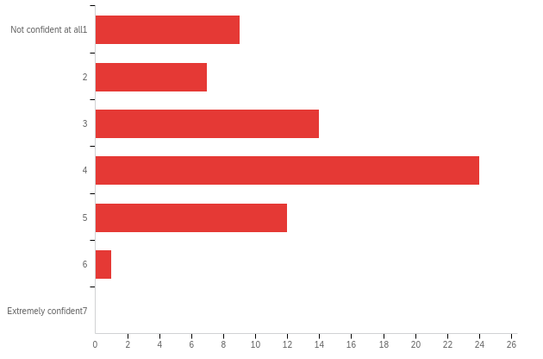

# | Field | Minimum | Maximum | Mean | Std Deviation | Variance | Count
1 | How confident are you that this answer is at least approximately correct? | 1.00 | 6.00 | 3.39 | 1.30 | 1.70 | 67

# | Answer | % | Count
1 | Not confident at all  1 | 13.43% | 9
2 | 2 | 10.45% | 7
3 | 3 | 20.90% | 14
4 | 4 | 35.82% | 24
5 | 5 | 17.91% | 12
6 | 6 | 1.49% | 1
8 | Extremely confident  7 | 0.00% | 0
 | Total | 100% | 67

noconv_large_comp_a - On average, how good do you think these players are at the game?
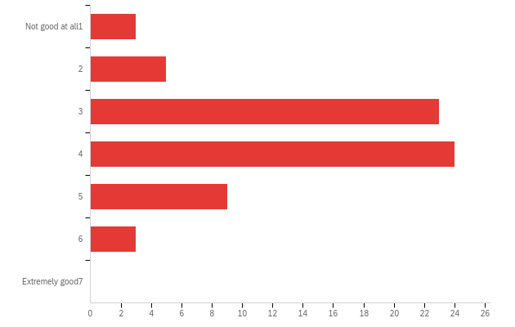

# | Field | Minimum | Maximum | Mean | Std Deviation | Variance | Count
1 | On average, how good do you think these players are at the game? | 1.00 | 6.00 | 3.60 | 1.09 | 1.20 | 67

# | Answer | % | Count
1 | Not good at all  1 | 4.48% | 3
2 | 2 | 7.46% | 5
3 | 3 | 34.33% | 23
4 | 4 | 35.82% | 24
5 | 5 | 13.43% | 9
6 | 6 | 4.48% | 3
8 | Extremely good  7 | 0.00% | 0
 | Total | 100% | 67

noconv_large_guess_b - What would you guess is the correct answer, if there is one?

# | Field | Minimum | Maximum | Mean | Std Deviation | Variance | Count
1 | 1 | 1244.00 | 1835.00 | 1612.09 | 73.48 | 5399.78 | 67

noconv_large_conf_b - How confident are you that this answer is at least approximately correct?
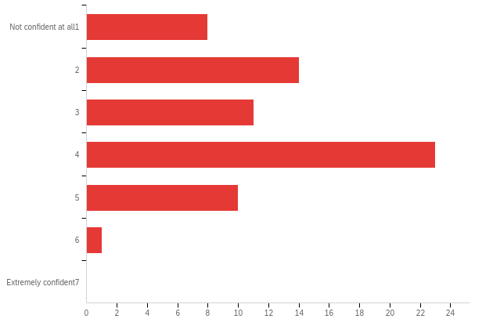

# | Field | Minimum | Maximum | Mean | Std Deviation | Variance | Count
1 | How confident are you that this answer is at least approximately correct? | 1.00 | 6.00 | 3.24 | 1.31 | 1.70 | 67

# | Answer | % | Count
1 | Not confident at all  1 | 11.94% | 8
2 | 2 | 20.90% | 14
3 | 3 | 16.42% | 11
4 | 4 | 34.33% | 23
5 | 5 | 14.93% | 10
6 | 6 | 1.49% | 1
8 | Extremely confident  7 | 0.00% | 0
 | Total | 100% | 67

noconv_large_comp_b - On average, how good do you think these players are at the game?
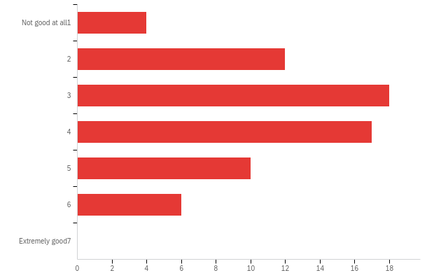

# | Field | Minimum | Maximum | Mean | Std Deviation | Variance | Count
1 | On average, how good do you think these players are at the game? | 1.00 | 6.00 | 3.52 | 1.34 | 1.80 | 67

# | Answer | % | Count
1 | Not good at all  1 | 5.97% | 4
2 | 2 | 17.91% | 12
3 | 3 | 26.87% | 18
4 | 4 | 25.37% | 17
5 | 5 | 14.93% | 10
6 | 6 | 8.96% | 6
8 | Extremely good  7 | 0.00% | 0
 | Total | 100% | 67

noconv_small_guess_a - What would you guess is the correct answer, if there is one?

# | Field | Minimum | Maximum | Mean | Std Deviation | Variance | Count
1 | 1 | 1248.00 | 1759.00 | 1483.18 | 58.58 | 3431.22 | 67

noconv_small_conf_a - How confident are you that this answer is at least approximately correct?
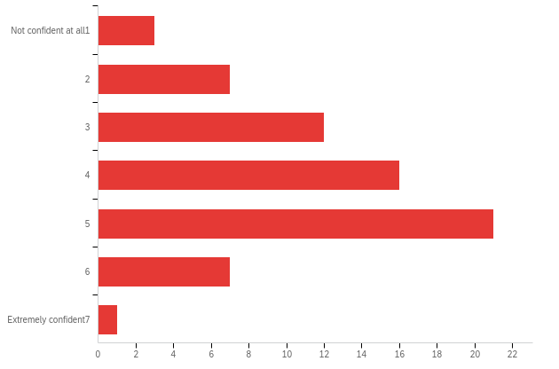

# | Field | Minimum | Maximum | Mean | Std Deviation | Variance | Count
1 | How confident are you that this answer is at least approximately correct? | 1.00 | 8.00 | 4.06 | 1.40 | 1.97 | 67

# | Answer | % | Count
1 | Not confident at all  1 | 4.48% | 3
2 | 2 | 10.45% | 7
3 | 3 | 17.91% | 12
4 | 4 | 23.88% | 16
5 | 5 | 31.34% | 21
6 | 6 | 10.45% | 7
8 | Extremely confident  7 | 1.49% | 1
 | Total | 100% | 67

noconv_small_comp_a - On average, how good do you think these players are at the game?
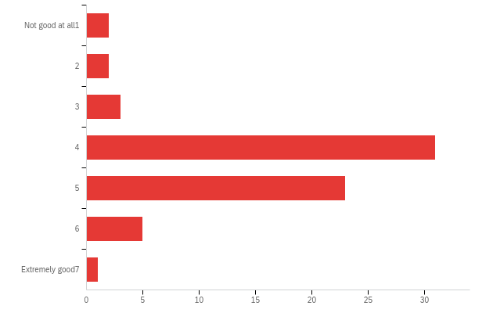

# | Field | Minimum | Maximum | Mean | Std Deviation | Variance | Count
1 | On average, how good do you think these players are at the game? | 1.00 | 8.00 | 4.36 | 1.09 | 1.19 | 67

# | Answer | % | Count
1 | Not good at all  1 | 2.99% | 2
2 | 2 | 2.99% | 2
3 | 3 | 4.48% | 3
4 | 4 | 46.27% | 31
5 | 5 | 34.33% | 23
6 | 6 | 7.46% | 5
8 | Extremely good  7 | 1.49% | 1
 | Total | 100% | 67

noconv_small_guess_b - What would you guess is the correct answer, if there is one?

# | Field | Minimum | Maximum | Mean | Std Deviation | Variance | Count
1 | 1 | 1090.00 | 1728.00 | 1357.64 | 97.89 | 9582.26 | 67

noconv_small_conf_b - How confident are you that this answer is at least approximately correct?
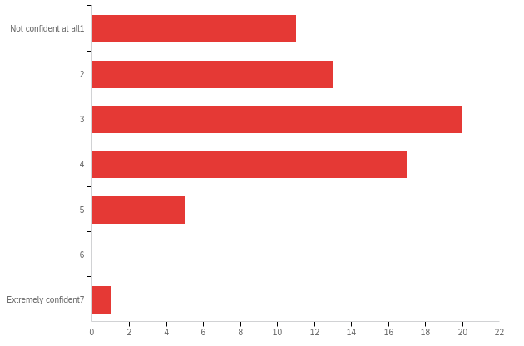

# | Field | Minimum | Maximum | Mean | Std Deviation | Variance | Count
1 | How confident are you that this answer is at least approximately correct? | 1.00 | 8.00 | 2.96 | 1.33 | 1.77 | 67

# | Answer | % | Count
1 | Not confident at all  1 | 16.42% | 11
2 | 2 | 19.40% | 13
3 | 3 | 29.85% | 20
4 | 4 | 25.37% | 17
5 | 5 | 7.46% | 5
6 | 6 | 0.00% | 0
8 | Extremely confident  7 | 1.49% | 1
 | Total | 100% | 67

noconv_small_comp_b - On average, how good do you think these players are at the game?
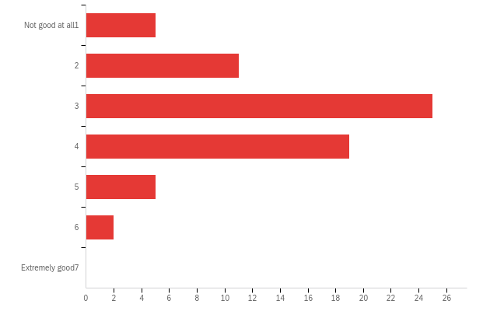

# | Field | Minimum | Maximum | Mean | Std Deviation | Variance | Count
1 | On average, how good do you think these players are at the game? | 1.00 | 6.00 | 3.21 | 1.13 | 1.27 | 67

# | Answer | % | Count
1 | Not good at all  1 | 7.46% | 5
2 | 2 | 16.42% | 11
3 | 3 | 37.31% | 25
4 | 4 | 28.36% | 19
5 | 5 | 7.46% | 5
6 | 6 | 2.99% | 2
8 | Extremely good  7 | 0.00% | 0
 | Total | 100% | 67

Q2 - Before finishing, please provide the following information. Once you are done with these questions, please do not forget to press the arrow to complete the survey and get your completion code.


# | Field | Minimum | Maximum | Mean | Std Deviation | Variance | Count
1 | Before finishing, please provide the following information. Once you are done with these questions, please do not forget to press the arrow to complete the survey and get your completion code. | 0.00 | 0.00 | 0.00 | 0.00 | 0.00 | 0

Answer | % | Count
Total |  | undefined

Q3 - What is your gender?
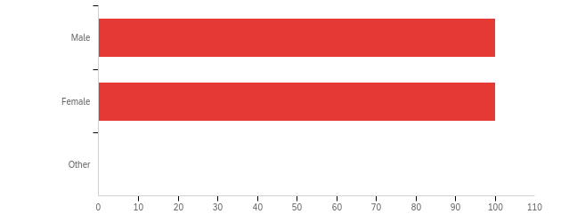

# | Field | Minimum | Maximum | Mean | Std Deviation | Variance | Count
1 | What is your gender? | 1.00 | 2.00 | 1.50 | 0.50 | 0.25 | 200

# | Answer | % | Count
1 | Male | 50.00% | 100
2 | Female | 50.00% | 100
3 | Other | 0.00% | 0
 | Total | 100% | 200

Q4 - What is your age?

What is your age?
21
56
35
38
38
65
65
52
32
34
48
39
28
62
53
25
40
44
45
69
63
59
58
23
45
32
58
26
20
34
28
23
22
23
49
66
25
57
24
58
34
60
42
20
30
21
38
58
52
27
70
49
50
29
36
21
56
37
21
31
75
24
23
42
69
23
57
79
33
59
32
37
30
36
63
29
19
37
51
20
34
60
39
29
50
46
32
21
58
33
27
27
31
20
63
28
37
56
19
63
38
39
55
45
67
63
36
31
42
19
34
72
62
41
36
43
65
24
52
68
60
46
42
37
30
29
29
53
31
28
30
29
39
19
23
64
40
25
19
21
66
32
61
46
19
23
25
25
29
47
33
31
33
19
59
59
36
65
29
26
30
58
30
24
51
26
25
27
18
58
54
26
28
28
59
69
21
23
35
34
26
45
25
32
49
39
22
52
61
53
51
66
21
33
33
32
29
24
34
31

Q5 - What is the highest level of education you have completed?
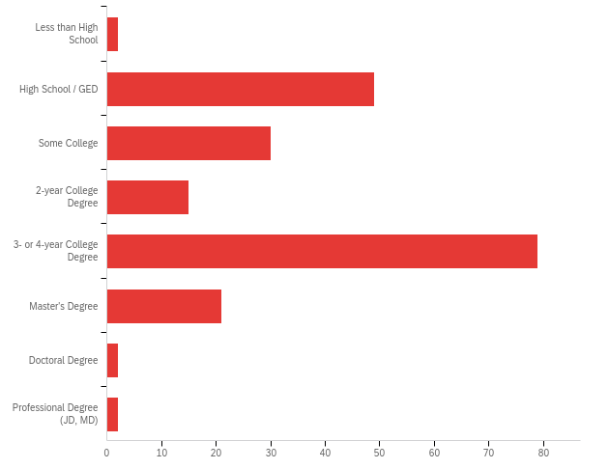

# | Field | Minimum | Maximum | Mean | Std Deviation | Variance | Count
1 | What is the highest level of education you have completed? | 1.00 | 8.00 | 4.00 | 1.51 | 2.28 | 200

# | Answer | % | Count
1 | Less than High School | 1.00% | 2
2 | High School / GED | 24.50% | 49
3 | Some College | 15.00% | 30
4 | 2-year College Degree | 7.50% | 15
5 | 3- or 4-year College Degree | 39.50% | 79
6 | Master's Degree | 10.50% | 21
7 | Doctoral Degree | 1.00% | 2
8 | Professional Degree (JD, MD) | 1.00% | 2
 | Total | 100% | 200

PROLIFIC_PID

PROLIFIC_PID
5eb151cc6e76f820eb3a330b
5ecd22e76997ec03464c71aa
5f3a9a262fd4896cfdf870a8
60ccc83bea0576d2f30da90b
5aa7e3a66475f90001a06f7e
5f9eb2b4530d3e45e450e42e
575eab31862b0f0006cd7dec
6156fef1e85e93bd92ba45ee
5a847fd2aa46dd00016ba03c
59655329a670a10001942540
5c463bc8b05faa0001d62716
5ea6eba9aba41b078b6a832f
5e2a2b0f3d25b70994890969
622a6dc874038359001a9e95
60264f219516732a1dc72394
6123a6a7ecf260c2a9b25733
60c71db92651d246c6081107
611641c6583d8bab5012dee0
5ddd9d0e40460ecfff653cb5
5abf047d1667e40001d82e45
5eac70db94edd22d57fa00c4
5ddba1b941fb3fae60ceb0c3
5ee935230c3e3f2c25f6f83a
5e8ea111f5166b1680ef8eef
5d92145df583b100181423db
5b5477c2329be10001938ff8
5bc5be2572df5f00014479f9
5c86303fc2ceec001719a6eb
5c7fb04093cdce00160adf49
61f2adcea09e72f23cbaf96a
5ad2254db438910001ac9c31
5f53b73f18bf9a6ed513ca61
61486b40198550b29e7f29be
5f6f24f71b1cd746e9ded65e
5ea18fb96205ad04eae7342c
59a5fd55145f7000017ab7e3
5ffc8b3359c0d0096cc8e234
5cd942fdcc98b20019852b50
5eb84ddb1aa1b479b631a1fb
5aead25562ac0e00010974b1
5ee60e6af4d9c0366af53a7f
5d1b7ca2ebfae6001a9e4401
60435c1d1d1a6f2effcfb8f1
610af1f010f5e9cb15989d31
615f42ca58f6e800db5a9821
5e9b9eaee0e30b0b27983c50
5ed0dc47fd66121c75e88443
5db7203e98ecdf000ae8d504
5c65e8114f67dc0001542266
5a9ed3f26219a30001f54e85
59e8a9b1d838ae0001850c89
5f09fab615ee6b0ab5235b15
601c141abca398678a72ff4c
5dcf1031b039ab061db5243e
5ac499001667e40001d859f9
5d352f8bb02857001963539a
56278536ddff3c0005bcdad9
5e737c034da556000ac9d606
6026e1c91fcd140c25ec6076
60b4ae00a553ce01ecec6699
5ed8f853923c0941e1238299
5e570f6b38fb3a0d3c15e266
5cfbef1b50597d0001e8f11e
5ee013785a5719357e9ce0cf
577f91b84d107800016d9e69
5ed00b67157bd20c24f3fc51
59e4fe99c0d35a0001294f8b
5c6e591fc114eb00018b2633
60858fa033677878a8399e3a
5ea4115637284839f59110e1
5bab5f23fdc48b00017769b7
5afd6d5b56fe2c0001690178
5dbecb5e30c4d737494efe10
5be6f1cbeca90b0001e6e8d5
5a678d0bb9e3b50001a73fa3
5b1a88970ada0a0001e0f483
60d370d873117813ba043af5
5ea596f614912a579c4e52e1
59b57bccd98aab00019bb1a3
5fcd1c5584c8d416c797d96a
60c33f3e6706eca45e689ea4
6167116fd8a186cd98501614
602db1b6986cfd292b134d4c
5f76303f951dda087d02e0bc
5f64ea0392e24101c0bfaebe
5efad067339562914d784503
5e0f189d4c81b262eb326f2e
5f51114394f9472e53bc5936
589cb50d4d580c0001e09d16
6169d51314e3d1b78a88caf1
60882005bba3d0951e32e1b8
612d1746a8d65bea189cd548
5f24a699b63d070b1fbc0619
5fd3fc5121ea1c140bf4a272
60f5569b3a95a18a91dc5d21
617285bcc61b22a31210faa3
5fad74db5cdcd70beb72b777
5cdd4befd3651c001950e539
5f05e24314e7c90bb6b43cc8
57e131b80cb6700001dd7e5c
588126f90234ec00016eff60
61656be3235b845792b267ba
5dab89f4e9adfe00173caa73
5fa951617709a108aeddcd53
5eea37b60e95520ef6907500
5bfa91cf26e31d00010462ed
5be87656822047000181d875
5ec6c8ad6f911e0e87e58b1f
60c347136d0a78b90bbd88e6
616823f4aacb6e9b1cde751c
5981b3289bf4fe0001070aea
5efb18d8ef19f5029af663a5
5c8ce2f39d2bff0001b3fcea
5c2004c3da51990001e165b2
5da855e8db29f000128d738a
5b27b81293707800011eabdd
5cb7be4c30e566001a8b04b5
5eeb9854ef20d70e582acebd
59205fcb97a88c000145d191
5f088147510abc0947ad09cb
54847094fdf99b0379939c8e
5c9b534b519f7500182be9b7
614721cb6d8ce56e9e7aff9d
6060dcaf19b714b145f5a5f3
5b74960f218c0f000107d480
5c2e5db32c45d400014a9b4e
592a232ed13ea60001553e51
611f6757f935f97babc092c5
5e19b6135bcd432316ad611d
6058d2405f4008ae73478bd5
610d44c612fa08637162fbd0
5cc4509c2daae1001987e95b
5c61598fb40f380001109ca5
61670802a36d216563a5bd60
5b92bd88f2ac7e0001d8a45f
56864f2f333cbd000c4e4db6
59bad6a60ac77f0001f05254
5f7b18a04caba9049fd3283a
6106919acfdc82263f1297d9
5eff26cb359bc645ec530cbb
5f57fd0328b04b3489d452e9
5e23175dd84c1b5ca13b1cd0
6125067aa09e6b144c8ec8b6
5e285f486167be038c5c0a49
5eb4841544c2df2f0190e8a0
5cf9c2d6dfcf0a0015e8e213
5f751715d7804519031aa4f2
5fc8f86079e4a6306ef1616e
5e072bb71d6b460b5e6eae99
5f562fc05e6f8a000965cbd5
5d78cb8a44b0d10001a53485
60b7f102c27f0b693919fc98
5784d25070c76a00012427e0
5f1c62b6554a0f4f129c75fd
5ce43a70aade7100152e6e77
56a7da16c89737000b22953c
5e550321537ed2000b1e5ad2
5c472ac67379d8000112983d
591c58daa940aa0001f1bd8f
5b846cdbcecee70001351e21
5d4934304c12d50015ec3e1f
5db92f4d8e9761000d7d7a8b
5d5357e0b45aff0001980d13
614ef5b48e102069659031ba
5a7094c4f660ae0001a98bd5
5ecc2a43543cc180222321d3
5f60abca7aa062068858abaf
60fd0fdd7e3e57ca7d5182f1
60bd0b154d2a4347a66b551e
5e59982929132107a864c783
5978c32bcae3340001134a46
6140e3be2e0c5456ad63dbdd
5f0f4a855137200d21e1befe
5c865d87d6a29e00172eefb4
5680452cc5767f00121cc81a
5ea133c68d67911401c2ea57
5e53f975e61d06022f73e241
5ec3eabec8f93307a60c5d1b
5958dfbc8c7f1a00013bd0b9
5a238241a7788f000144aca2
5fe1f5f751f3a9ceb57d935a
5cdef91bf4acd700153ac9db
5e32f669641109012e2a0531
5f62521ef07ba314e1e297d6
5fe0f4a8e6b281af7dd9de1a
5eb1614dfff7a624f18e62be
603acc04f7671274214e49b2
5ea048ef3427cf06b692b9d4
5953acc10dd7710001aec19e
614f9daff9b7bf1a0f4c4f9c
600a878fa6fbbf1ba60bea36
5bbfa1a41ff4ba00011c330b
5becb1e76a75a100010b7f75
56e1bb4e6ce054000b3ffcaf
5e15047894d5eeb157532e7f
611107eaa48093e17e7e56d2
5d548c047795f80001bf611f
5f14a3b0188dff519298a4c6
5ae7107c3b85e70001176dd4
61673c4003922ad28160efdd

counter

counter
8
8
8
8
8
8
8
8
8
8
8
8
8
8
8
8
8
8
8
8
8
8
8
8
8
8
8
8
8
8
8
8
8
8
8
8
8
8
8
8
8
8
8
8
8
8
8
8
8
8
8
8
8
8
8
8
8
8
8
8
8
8
8
8
8
8
8
8
8
8
8
8
8
8
8
8
8
8
8
8
8
8
8
8
8
8
8
8
8
8
8
8
8
8
8
8
8
8
8
8
8
8
8
8
8
8
8
8
8
8
8
8
8
8
8
8
8
8
8
8
8
8
8
8
8
8
8
8
8
8
8
8
8
8
8
8
8
8
8
8
8
8
8
8
8
8
8
8
8
8
8
8
8
8
8
8
8
8
8
8
8
8
8
8
8
8
8
8
8
8
8
8
8
8
8
8
8
8
8
8
8
8
8
8
8
8
8
8
8
8
8
8
8
8
8
8
8
8
8
8

